2001
January 27th 2001
67.- A festive meeting was organized at the Foundation’s seat to “Celebrating the 3rd Millenium”. The New Year was welcomed by a joined prayer of the representatives of nine cults. They asked God for a flourishing country, tranquility and peace on earth. Event organized in collaboration with Mrs. Marcela Ghiulbenghian President of the “Sacred Treasure of Religions” Foundation and family, and Prof. Univ. Dr. Stan I Alexandru General Secretary of A.P.A.R. Father Prof. Galeriu, Father Munteanu Paul, Father Istodor Gheorghe, Pastor Albu Zoltan Zagoni, Father Sabău Cristian, Father Ţanu Nicolae, Caţi Camil, reverend Vexler, Father Decan Martincă, Titi Dincă director. TVR, Dăianu Valentin, Prof. Trif Victoriţa, Moldoveanu Ecaterina, Geamai Ilmie, Iordanide Olga, col. Vartic Gheorghe and others attended the festivity.

March 15th 2001
68.- At the “Golden Kebab” Restaurant was organized a “Pay respects to Imam Osman Aziz” anniversary for his 60th birthday. The representatives of five cults joined the festivity. Event organized in collaboration with Mrs. Marcela Ghiulbenghian President of the “Sacred Treasure of Religions” Foundation and Prof. Univ. Dr. Stan I Alexandru General Secretary of A.P.A.R. Senator Mr Adrian Păunescu, pastor Prof. Albu Zoltan Zagoni, rabbi leader Mr. Eliezer Glantz, Greek-Catholic father Suciu Traian, director Ioniţă from Ministry of Cults, counsellor Bob Surdu, Mr Dima – Adventist preacher, the president of orthodox, catholic and moslem women, Mr Caţi Camil, dir. TVR Titi Dincă, Eugenia Mihart, Mihaela Deşliu, Gelcu Maksutovici, Costin Spiridon, Dănescu Traian, general Negoşanu Gheorghe and others. It was handed the diploma and gold medal to rabbi leader Eleizer Glantz.
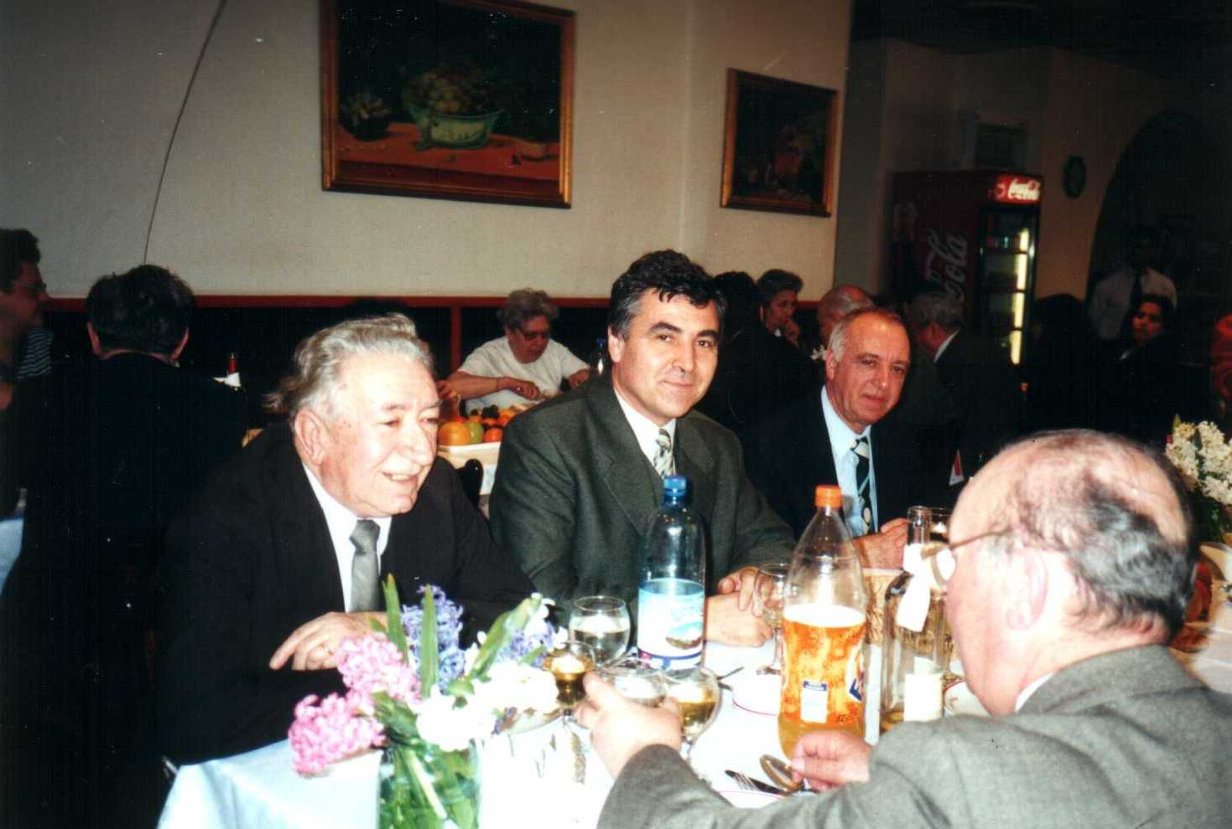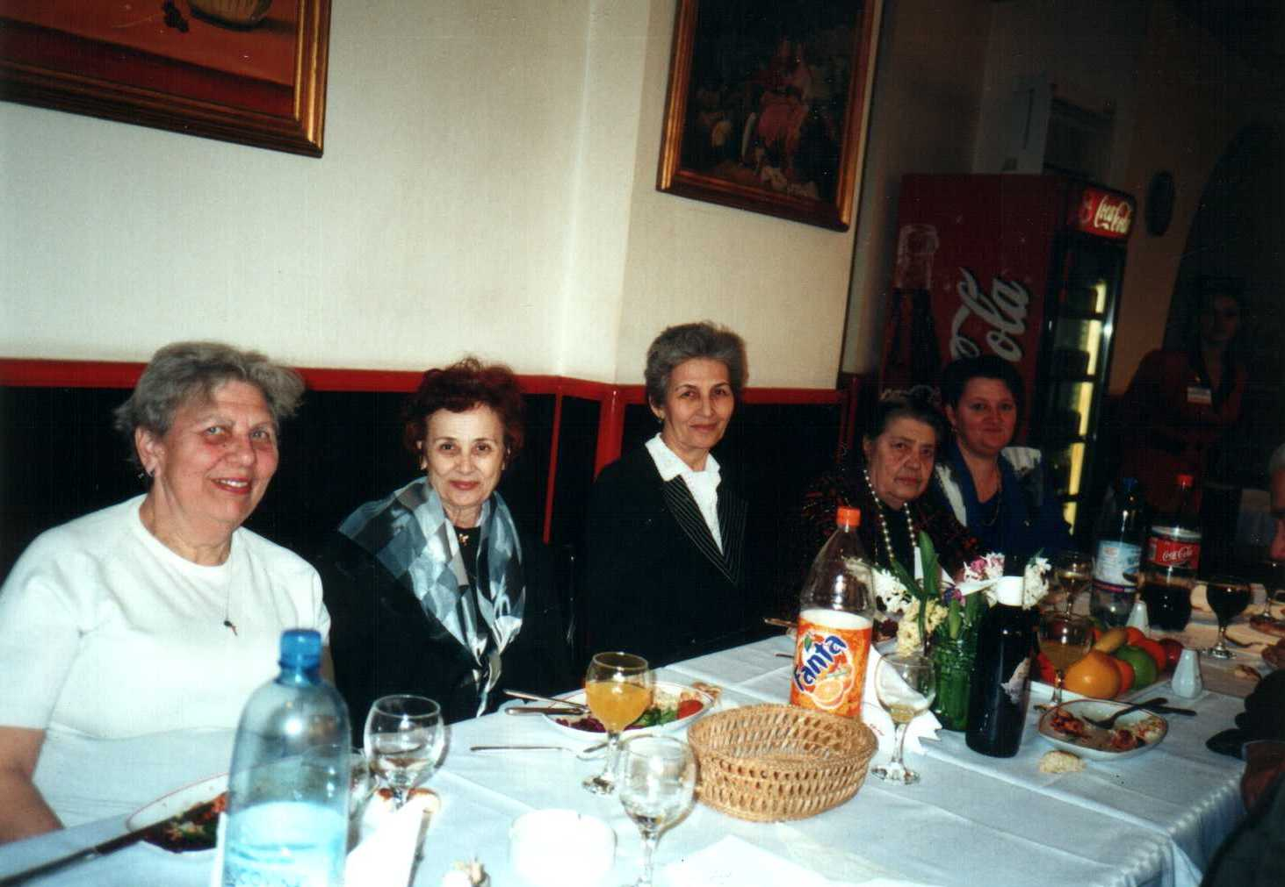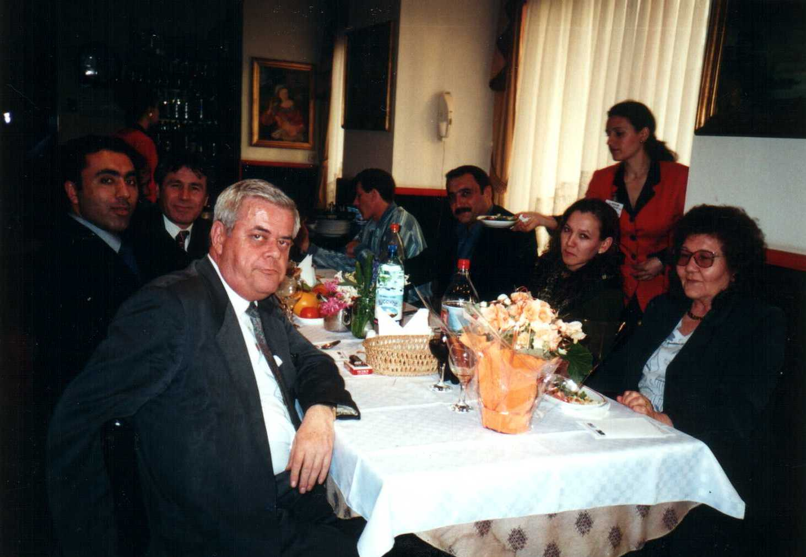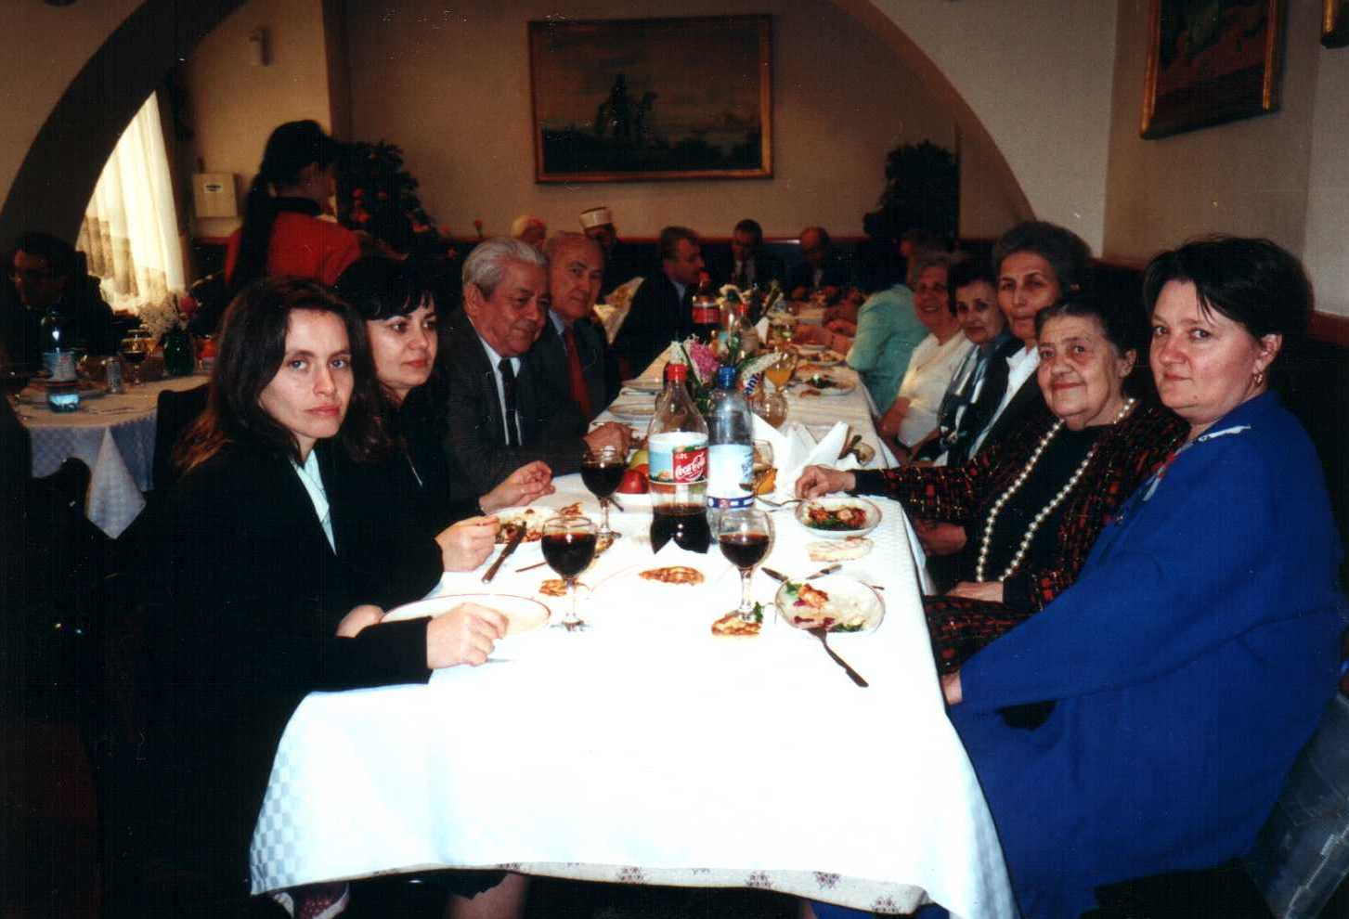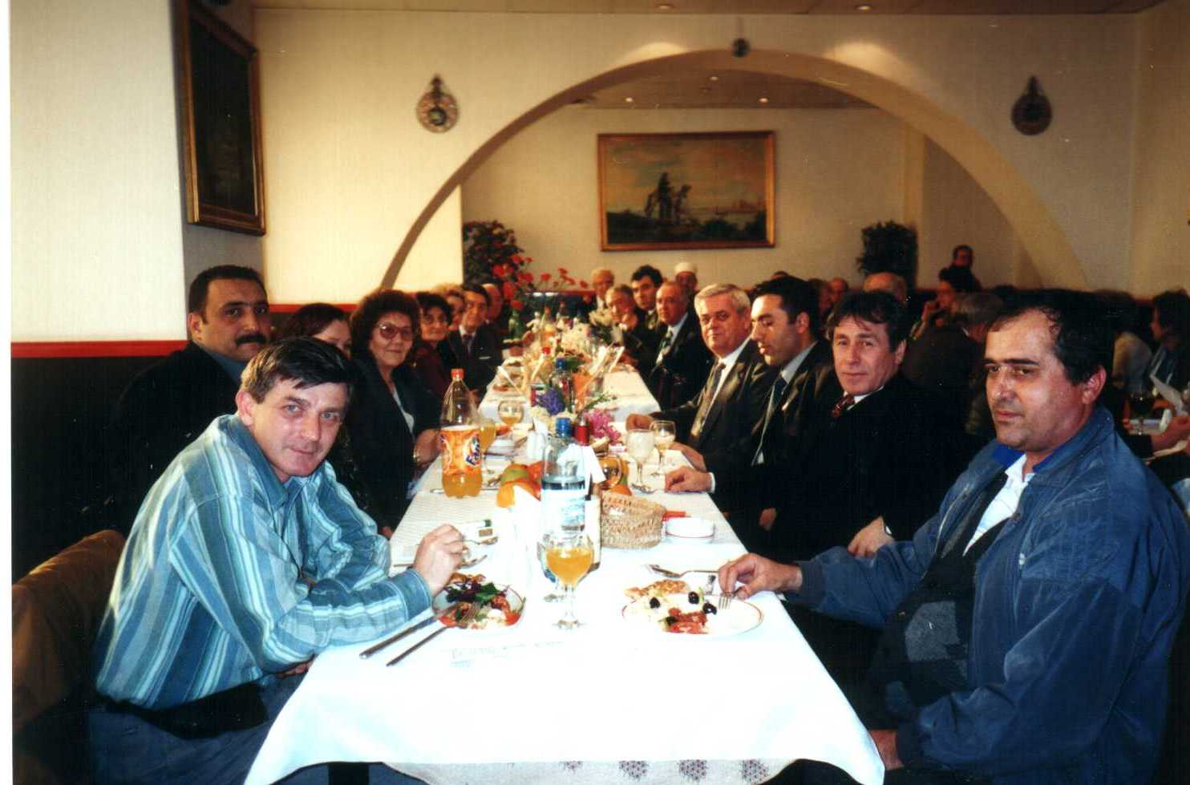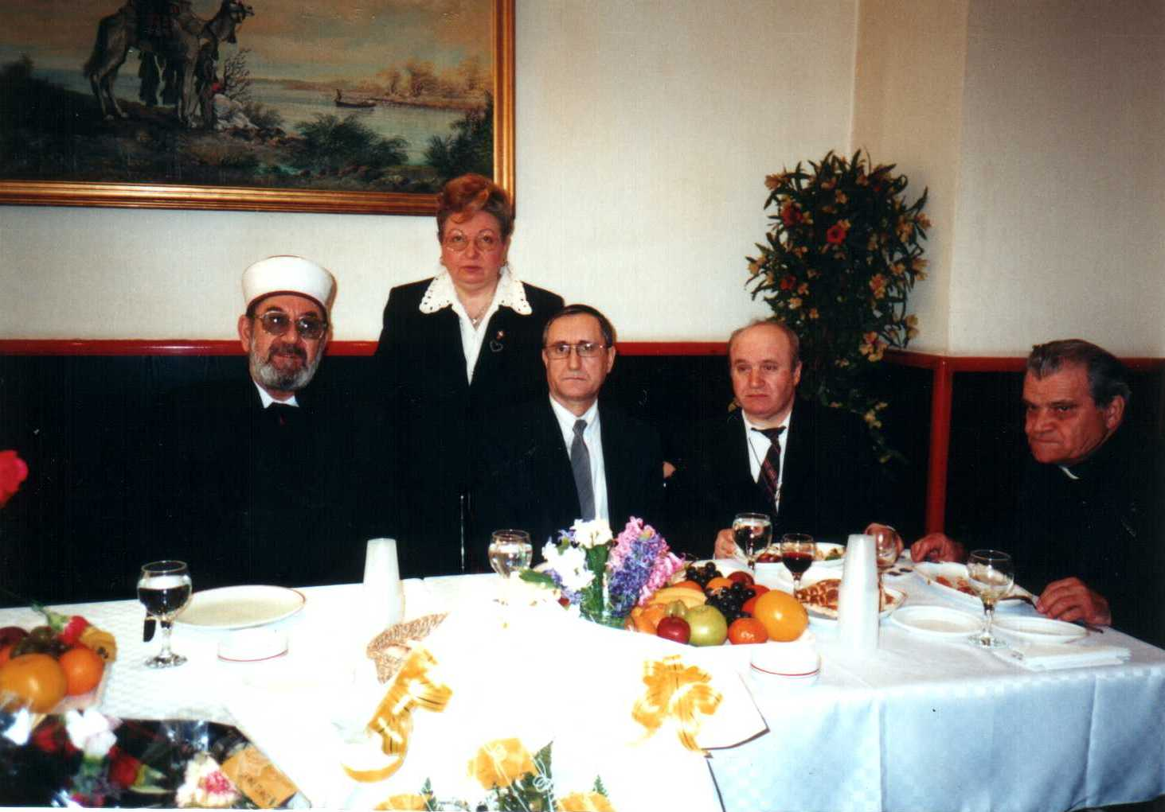

June 20th 2001
69.- A visit was organized at Cristina’s Monastery. This Holy place received many donations from Mrs. Marcela Ghiulbenghian President of the “Sacred Treasure of Religions” Foundation under the guidance of Father Sebastian.
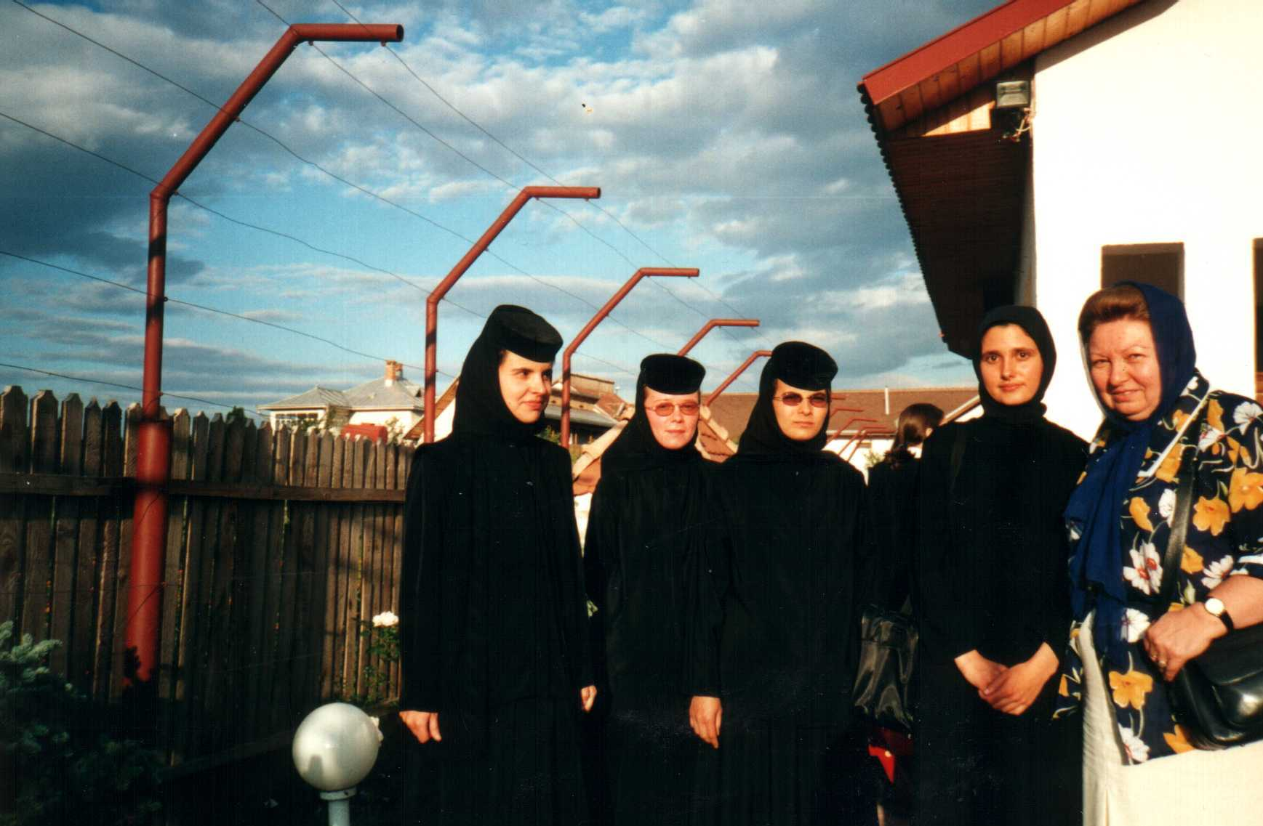

July 26th 2001
70.a.- A press conference was held at the Bucharest Lido Restaurant: “Achievements and perspectives of the “Sacred Treasure of Religions” Foundation followed by a breakfast feast. Event attended by: representatives of nine cults, media, press, Mrs. Marcela Ghiulbenghian and Prof. Univ. Dr. Stan I Alexandru General Secretary of A.P.A.R.
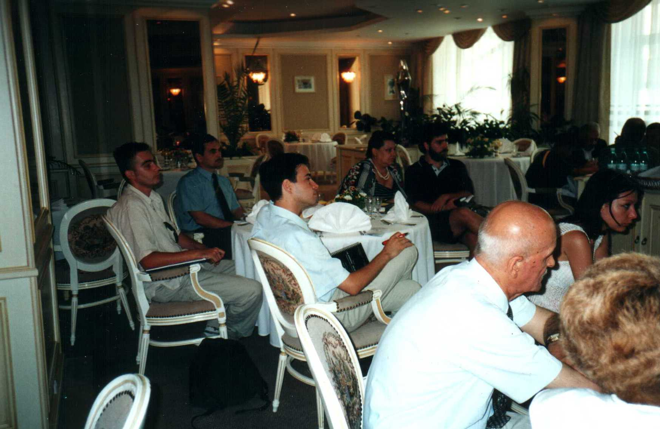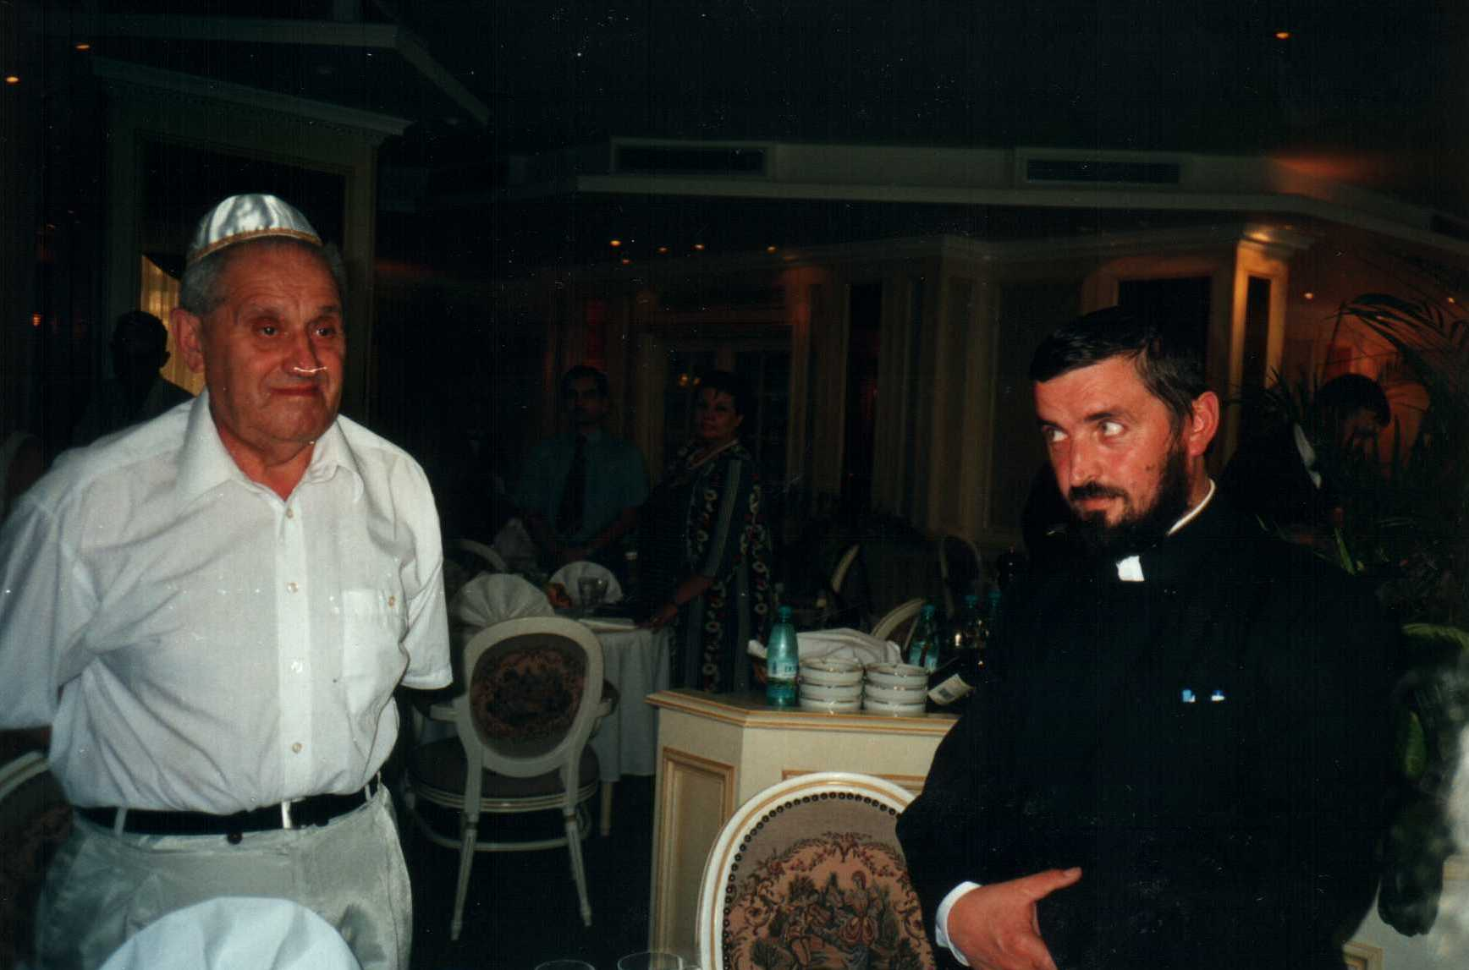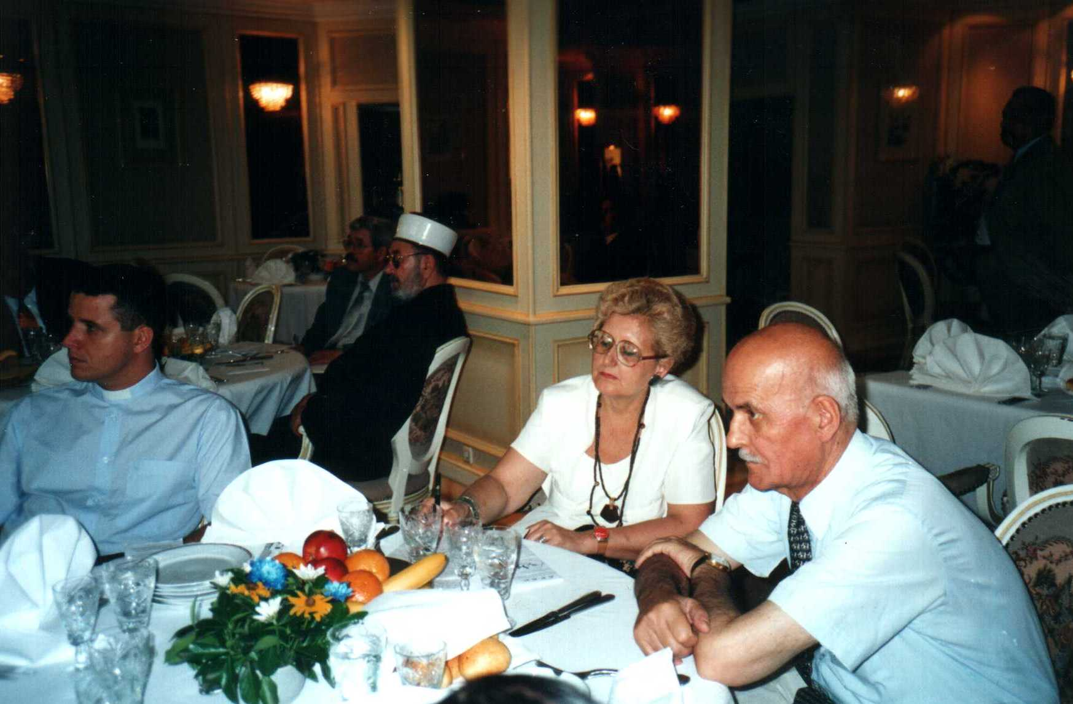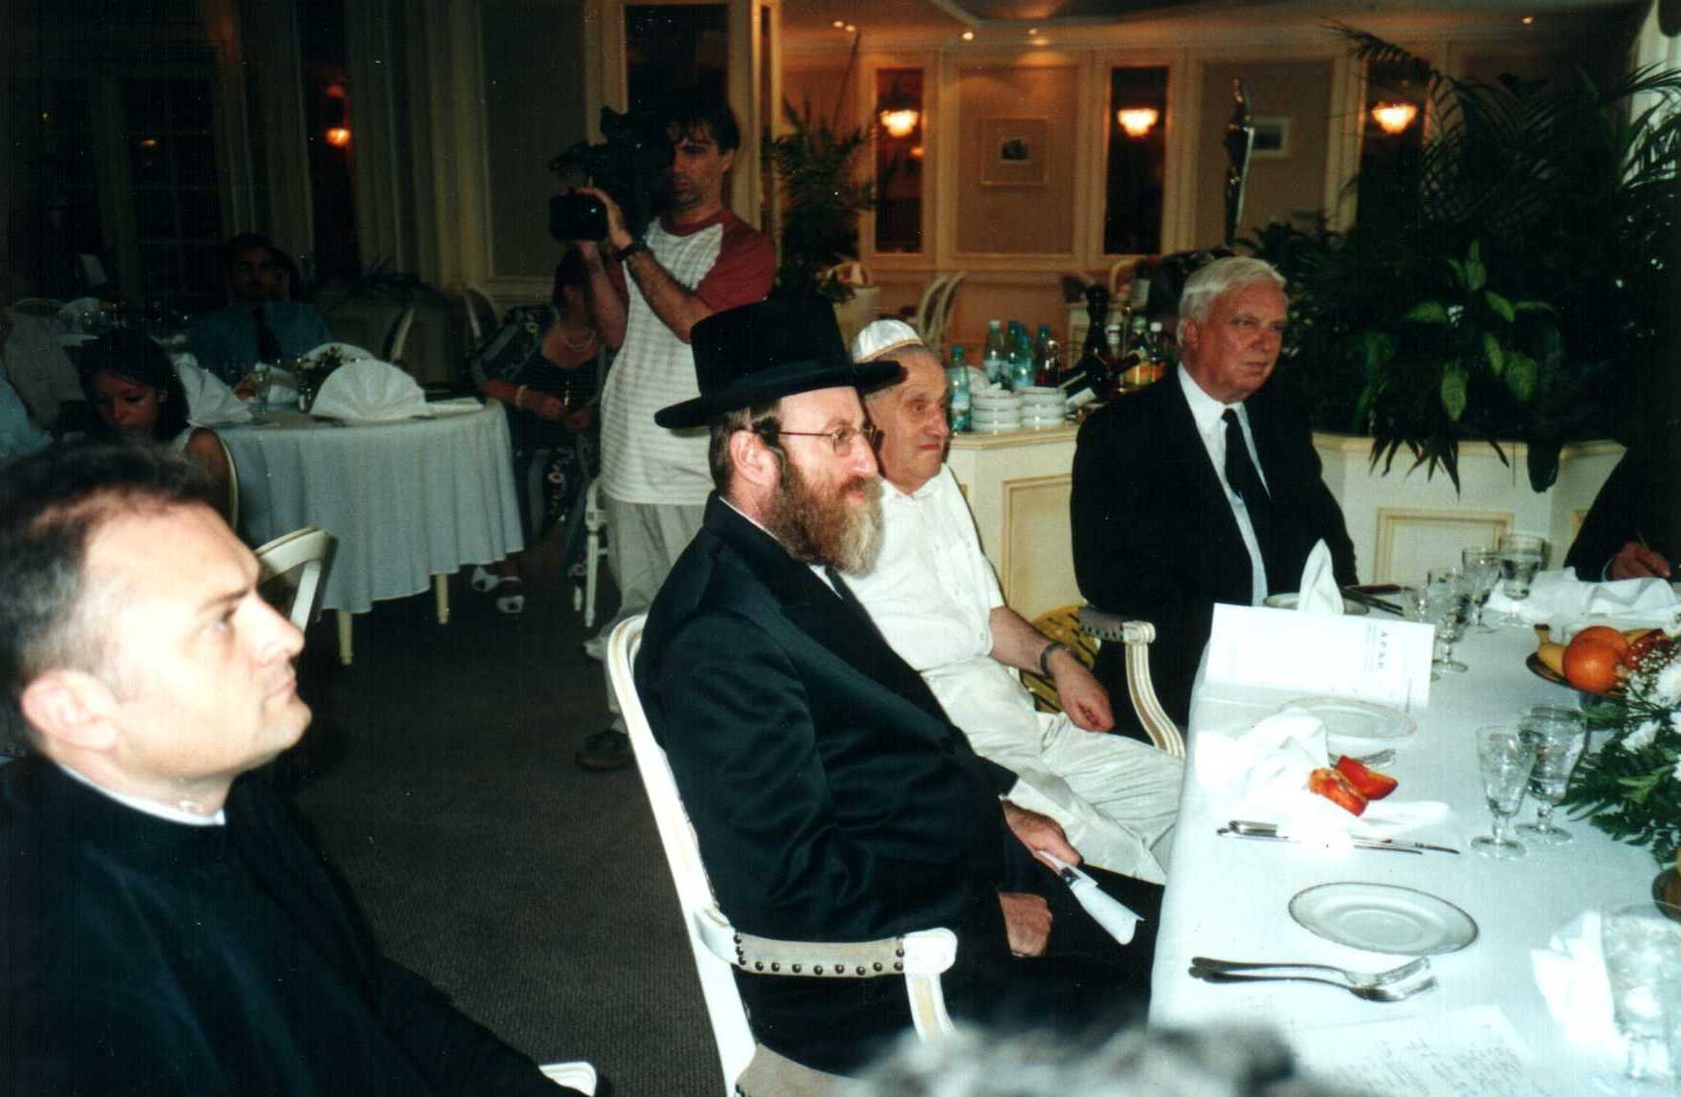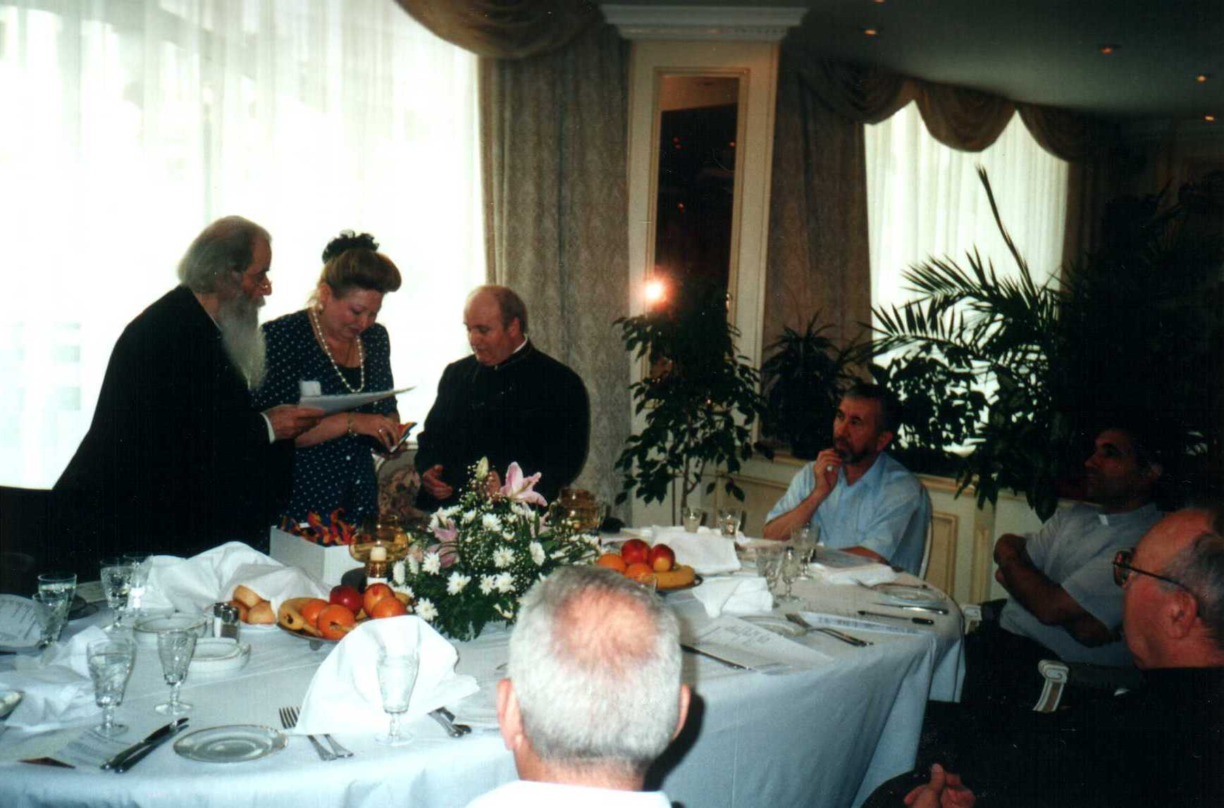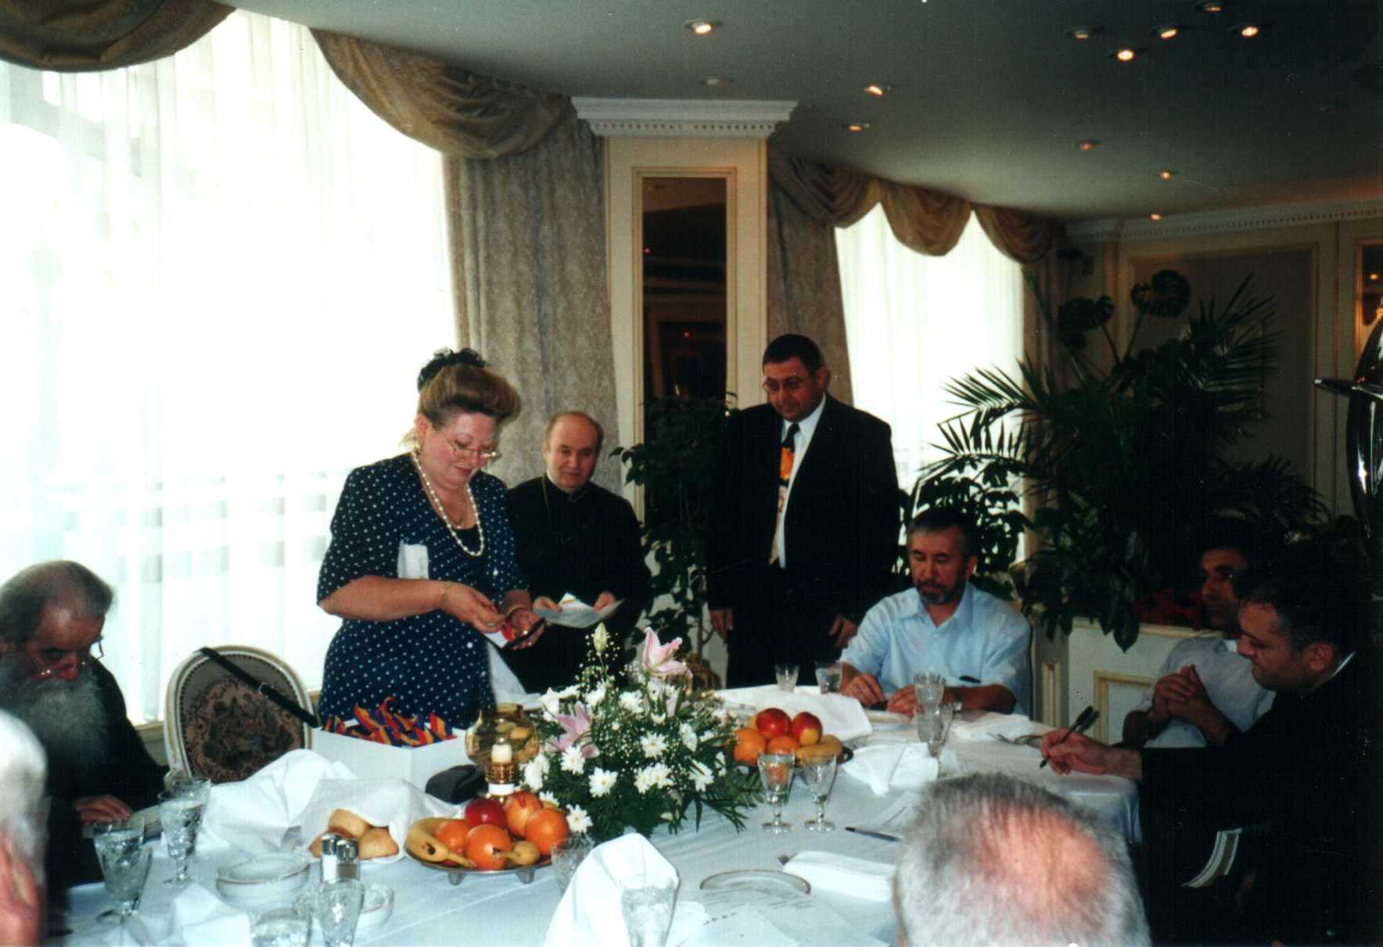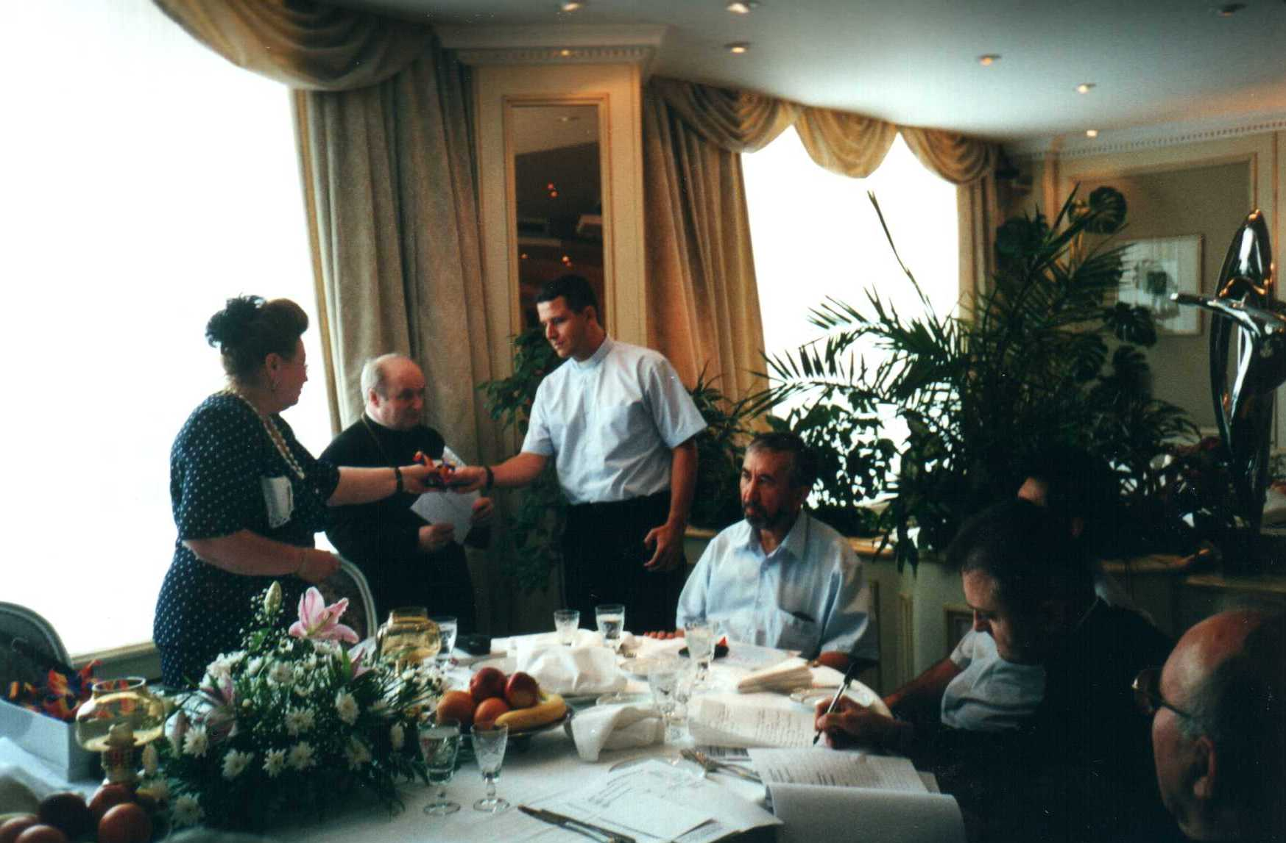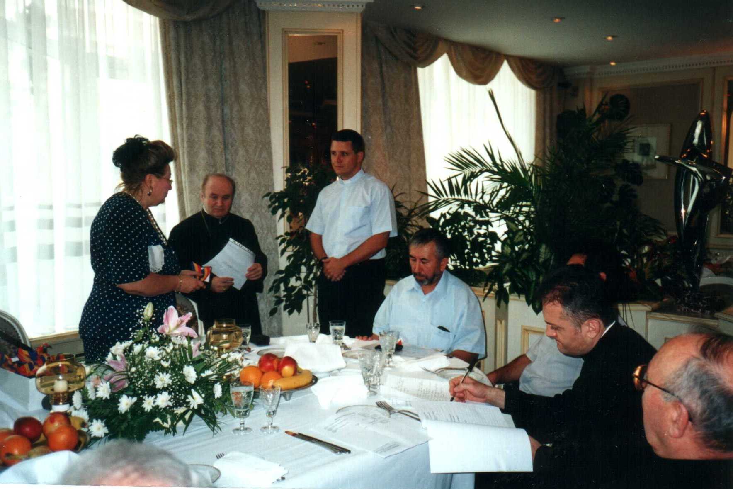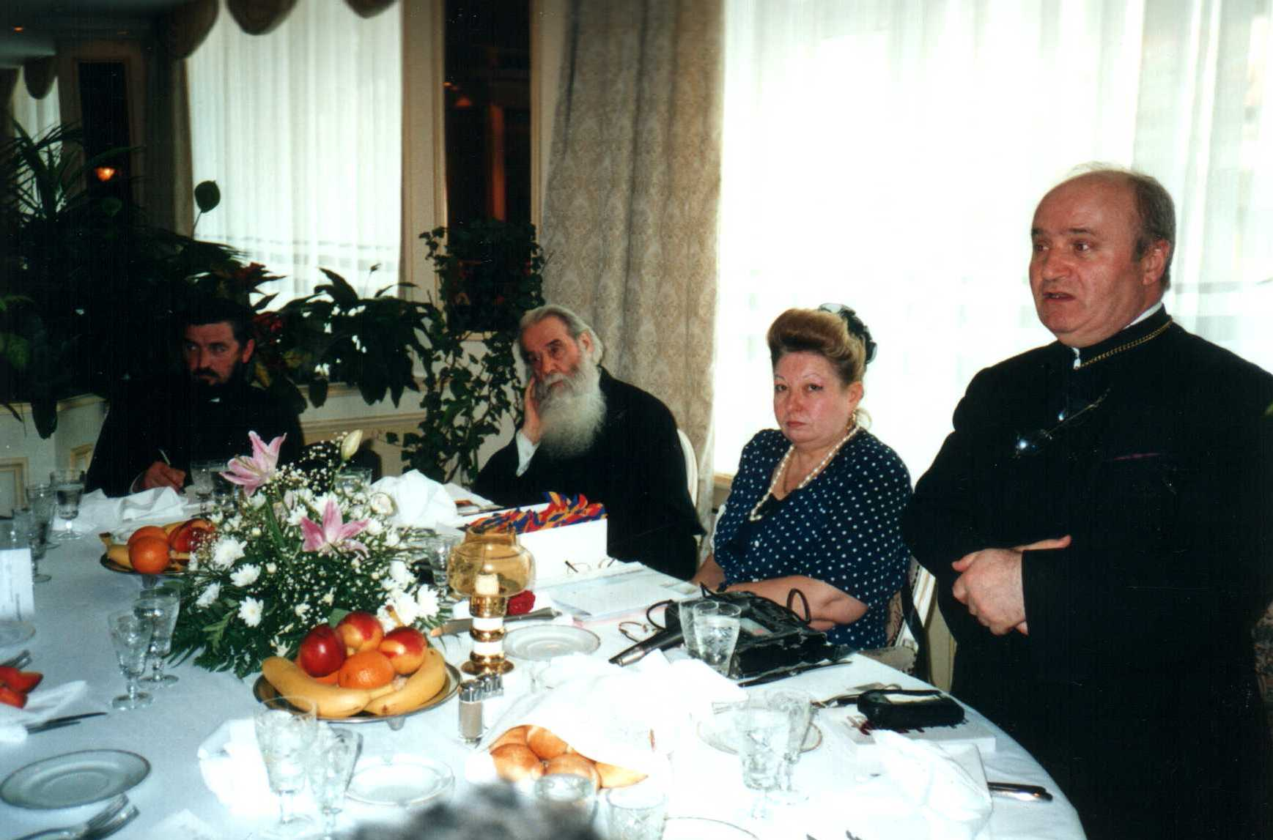

70.b.- Mrs. Marcela Ghiulbenghian President of the “Sacred Treasure of Religions” Foundation and rabbi leader Eleizer Glantz started the movie making at the Bucharest Temple, documenting the similarities between faiths.
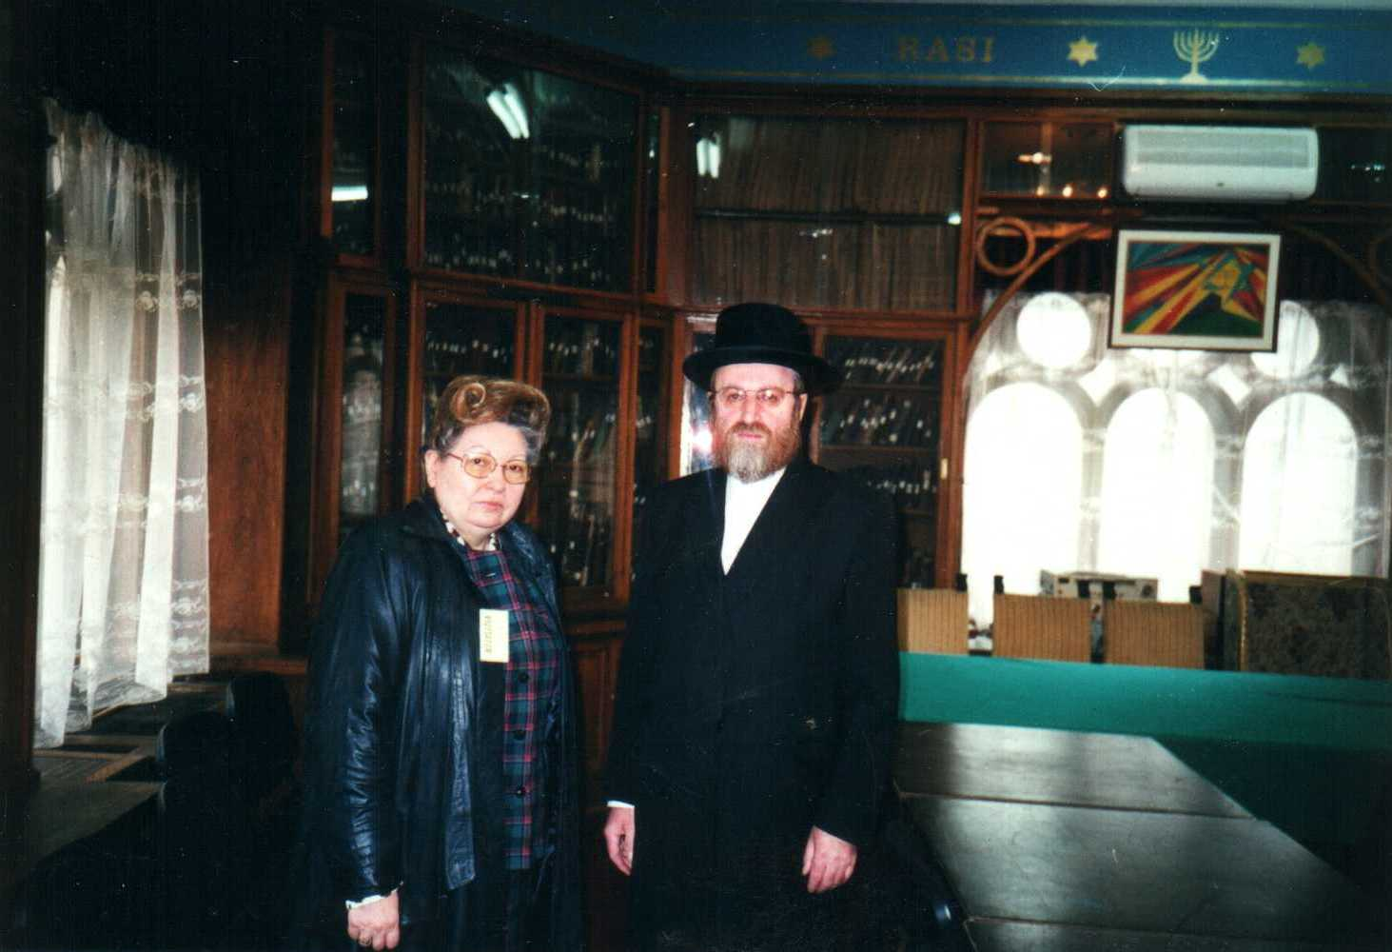

70.c.- Mrs. Marcela Ghiulbenghian participated in a field trip to Medjugorie along with a group of Catholics, Greek-Catholics, Orthodox and other faiths.
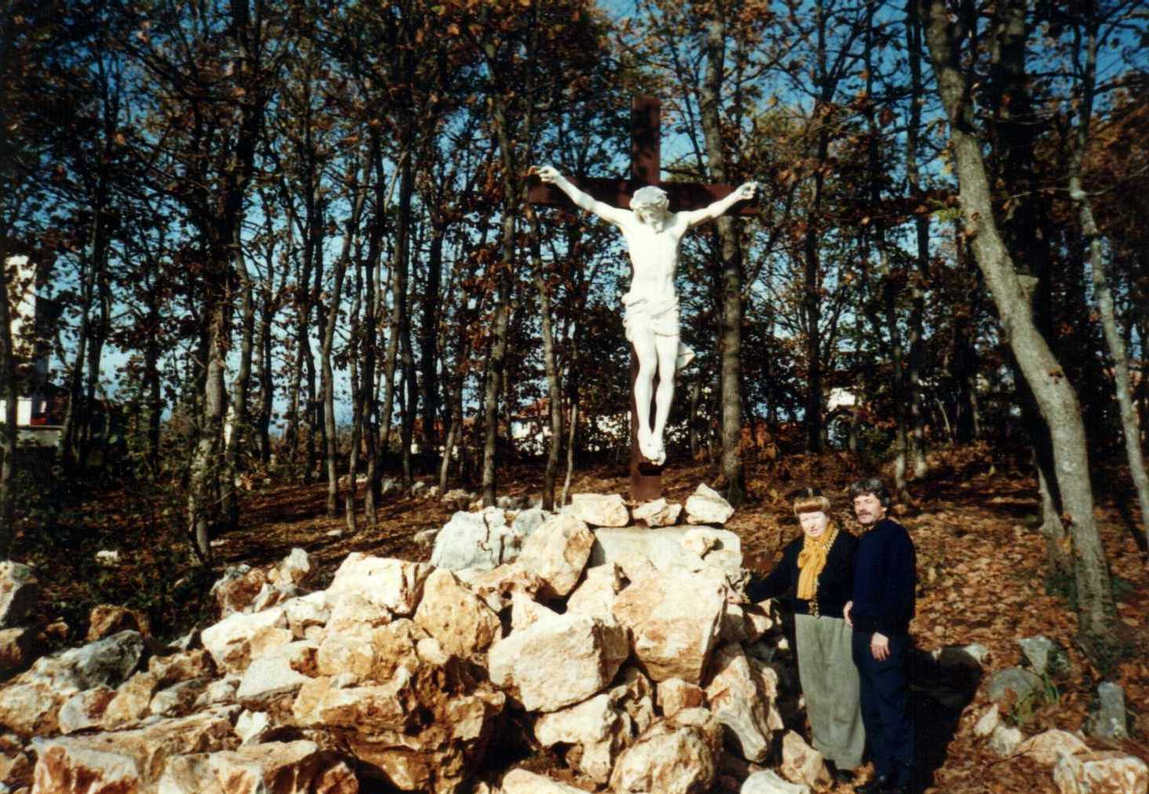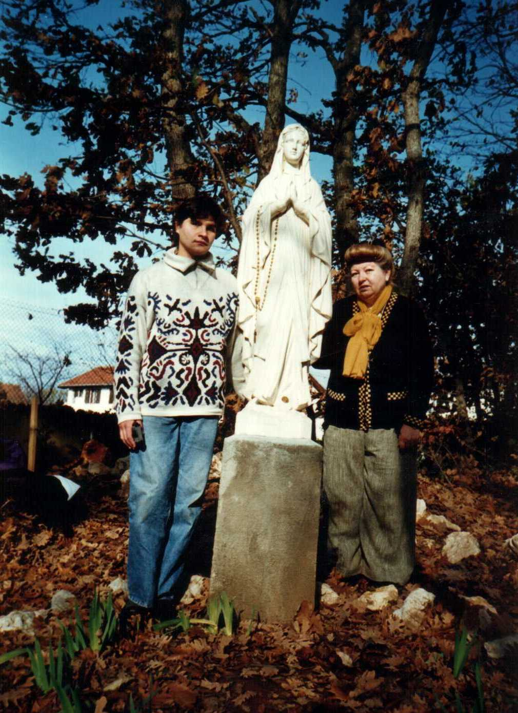

70. d - I created white and gray shirts, with our Lord JesusChrist and Holy Cross to celebrate 2000 yearssince He took the sins of mankind through the crucifixion on the Cross

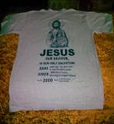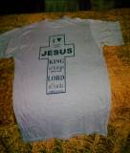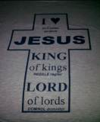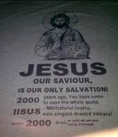

October 14th 2001
71.- Medals and diplomas were handed during a nomination festivity for the astounding achievements of involvement in the spiritual unity of faiths of His Holiness Antonie Plămădeală, Metropolitan bishop of Transilvania, Maramures and Crişana, from the Sibiu Metropolitan Church, by the President of the Foundation, Mrs. Marcela Ghiulbenghian and Ft. Prof. dr. Alexandru I.. Stan. On the way back, they visited Brancoveanu Monastery and Fr. Prof dr. Teofan Pîrîianu where Ft. Antonie Plămădeală arranged a very nice museum of ancient cults art effects.
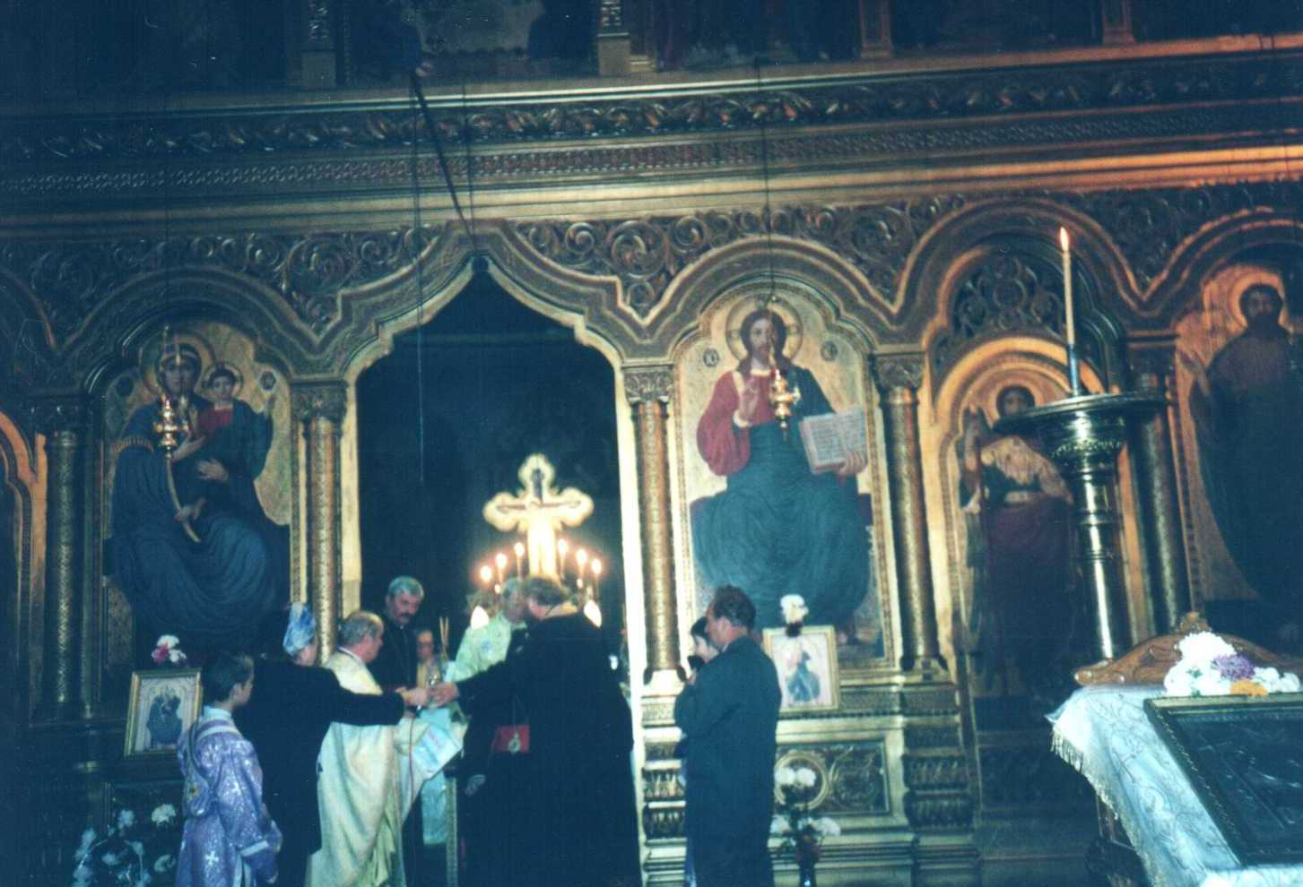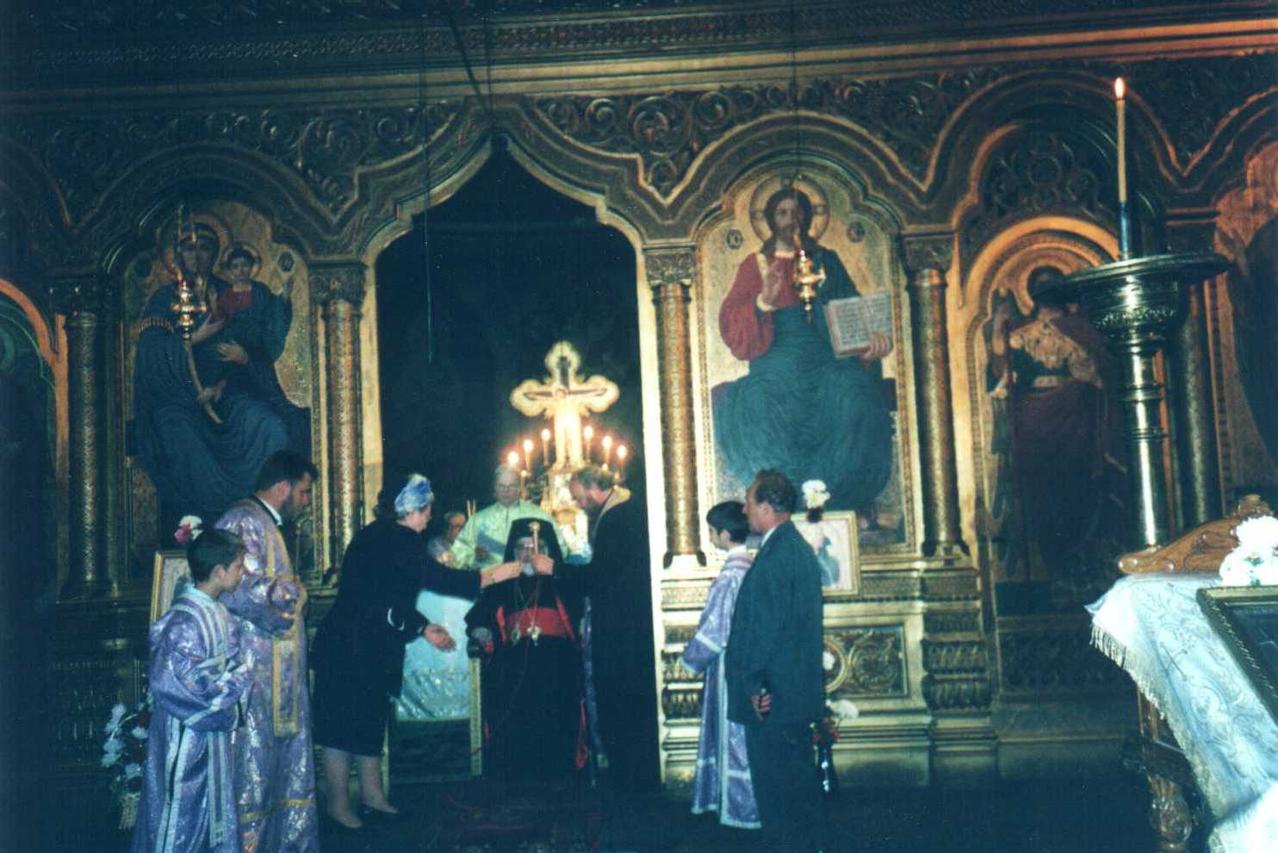

December 1st 2001
72.- A Christmas carol concert was organized by a group of eight theologian students sponsored by the Foundation (Niţă Adrian, Niţă Janet, Ionescu Valentina, Stoenescu Dan, Dobre Radu, Mihai Genoveva). They caroled various commercial companies, orphanages and asylums.
72. a) Ms. Marcela Ghiulbenghian sponsored book publishing and printing “ Tara soarelui sau istoria Daco-Romaniei” of Father Dumitru Balasa.


